Documentation of Complex Works

Accession No.
Artist/Designer(s):
Title:
Year:
Materials:

Significant properties of the work/statement of significance:

Functional description (1-2 paragraph describing the basic technical processes present in the work):

Status of physical components (type, brief description of the core element(s), and condition/vulnerabilities):

Status of digital components (type, brief description of the core element(s), and condition/vulnerabilities, if known):

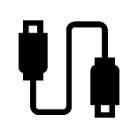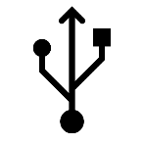
Status of peripherals (other hardware, software, power supply, connectors): type, brief description of necessary equipment, accessories, and programs to execute the processes in the work and for display, and condition/vulnerabilities


Status of documentation (description - including location - of various forms of documentation that facilitate the care/conservation, and installation of the work)

Additional observations (anything that does not fit in the above):

Key risks (present and future):

Action needed (research, conservation, further examination, treatment, etc.):

Additional documentation:

-Take apart/teardown guides (official or otherwise)

-Service manual

-User manual

-Specs sheets

-Assembly schematics, circuit diagram, wiring diagrams of component assembly (these may or may not be included in service manuals as supplementary reference material)

-Datasheet for components (desirable for major/significant components available)

-Public or professional journal announcements for product releases (examples are desirable but not absolutely required)

-Advertisements

-Designer interviews or quotes from designer relating to this product

-Examples in other museum design collections?

Prepared by
Date

